Updated: October 2018

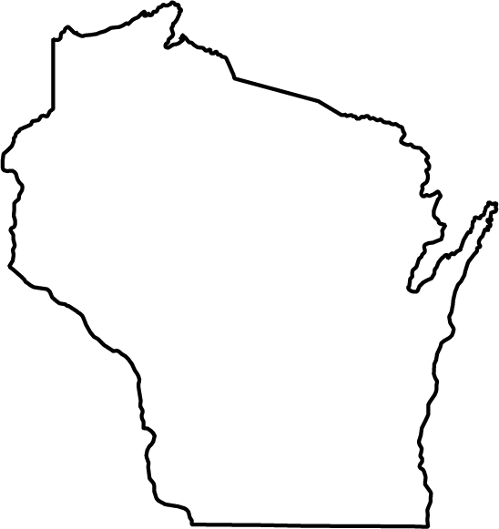

BPA Wisconsin
Calendar of Events

August 2018
Sunday | Monday | Tuesday | Wednesday | Thursday | Friday | Saturday
 |  |  | 1 | 2 | 3  Wisconsin Pages Now Available! | 4
5 | 6 | 7 | 8 | 9 | 10 | 11
12 | 13 | 14 | 15 | 16 | 17  BPA Alumni Conference in Wisconsin Rapids | 18
19  BPA Alumni Conference (Cont.) | 20 | 21 | 22 | 23 | 24 | 25
26 | 27 | 28 | 29 | 30 | 31
Visit BPA Shares (http://www.bpa.org/membership/bpashares) for help with recruiting, fundraising ideas, and much more!

Enter your Torch Points at least once a month to keep your Torch Resume up-to-date.

September 2018
Sunday | Monday | Tuesday | Wednesday | Thursday | Friday | Saturday
 |  |  |  |  |  | 1
2 | 3  Labor Day | 4 | 5 | 6 | 7 | 8
9 | 10 | 11 | 12 | 13 | 14 | 15
16 | 17  Constitution Day  (TAP 722) | 18 | 19 | 20 | 21 | 22
23 | 24 | 25 | 26 | 27 | 28 | 29
30 | Visit the Business Professionals of America website (http://www.bpa.org/membership/StudentCert) to learn more about the Student Certification Series!

October 2018
Sunday |  | Monday |  | Tuesday |  | Wednesday |  | Thursday | Friday |  | Saturday
 |  | 1 |  | 2 |  | 3 |  | 4  Student Certification Series Starts | 5 |  | 6
7 |  | 8  Columbus Day |  | 9 |  | 10 |  | 11 | 12  Deadline to Register for FLC |  | 13
14 |  | 15 |  | 16  Boss’s Day |  | 17 |  | 18 | 19 |  | 20
21 |  | 22  Fall Leadership Conference in La Crosse |  | 23 |  | 24 |  | 25 | 26 |  | 27
28 |  | 29 |  | 30 |  | 31  Halloween Day |  | Join our mailing list to receive more helpful tips throughout the year!  Now is a great time to start thinking about what our next state pin will look like.
November 2018
Sunday | Monday |  | Tuesday |  | Wednesday |  | Thursday |  |  | Friday |  | Saturday
 |  |  |  |  |  |  | 1 |  |  | 2 |  | 3
4 | 5 |  | 6 |  | 7 |  | 8 |  |  | 9 |  | 10
11 | 12  Veterans Day Observed  (TAP 722 & 724) |  | 13 |  | 14 |  | 15 |  |  | 16 |  | 17
18 | 19 |  | 20 |  | 21 |  | 22  Thanksgiving Day |  |  | 23 |  | 24
25 | 26 |  | 27 |  | 28 |  | 29 |  |  | 30

December 2018
Sunday | Monday | Tuesday | Wednesday | Thursday | Friday | Saturday
1
State Pin Contest Submission Deadline
2 | 3 | 4 | 5 | 6 | 7 | 8
9 | 10 | 11 | 12 | 13 | 14 | 15
16 | 17 | 18 | 19 | 20 | 21 | 22
23 | 24  Christmas Eve | 25  Christmas Day | 26 | 27 | 28 | 29
30 | 31  New Year’s Eve | TBD – Winter Boards

January 2019
Sunday | Monday | Tuesday | Wednesday | Thursdays | Friday | Saturday
 |  | 1  New Year’s Day | 2 | 3 | 4 | 5
6 | 7 | 8 | 9 | 10 | 11 | 12
13 | 14 | 15 | 16 | 17 | 18 | 19
20 | 21  Martin Luther King, Jr. Day | 22 | 23 | 24 | 25 | 26
27 | 28 | 29 | 30 | 31

February 2019
Sunday | Monday | Tuesday | Wednesday | Thursday | Friday | Saturday
 |  |  |  |  | 1  SLC Deadlines *See List Below | 2
3 | 4 | 5 | 6  Online Testing | 7 | 8 | 9
10 | 11 | 12  BPA WEEK TAP 322 | 13 | 14 | 15  State Leadership Conference in Rice Lake | 16
17 | 18 | 19 | 20 | 21 | 22 | 23
24 | 25 | 26 | 27 | 28
- Torch Awards (Statesman) WI BPA Cares
- Mike Tokheim Scholarship Application Member Recruiter of the Year
- WI State Officer Candidate Application Advisor of the Year
- WSAP Competitions and Pre-Submissions Community Service
Environmental Action and Awareness
Marketing and Public Relations
Special Olympics
March 2019
Sunday | Monday | Tuesday | Wednesday | Thursday | Friday | Saturday
 |  |  |  |  | 1 | 2
3 | 4 | 5 | 6 | 7 | 8 | 9
10 | 11 | 12 | 13 | 14 | 15 | 16
17 | 18 | 19 | 20 | 21 | 22 | 23
24 | 25 | 26 | 27 | 28 | 29 | 30
31 | National Deadlines will be added when determined

April 2019
Sunday | Monday | Tuesday | Wednesday | Thursday | Friday | Saturday
 | 1 | 2 | 3 | 4 | 5 | 6
7 | 8 | 9 | 10 | 11 | 12 | 13
14 | 15 | 16 | 17 | 18 | 19 | 20
21 | 22 | 23 | 24  Administrative Professionals Day | 25 | 26  Arbor Day  (TAP 215) | 27
28 | 29 | 30
May 2019
Sunday | Monday | Tuesday | Wednesday | Thursday | Friday | Saturday
 |  |  | 1  National Leadership Conference in Anaheim, California | 2 | 3 | 4
5  NLC  (Cont.) | 6 | 7  Teacher Appreciation Day | 8 | 9 | 10 | 11
12 | 13 | 14 | 15 | 16 | 17 | 18
19 | 20 | 21 | 22 | 23 | 24 | 25
26 | 27  Memorial Day | 28 | 29 | 30 | 31

June 2019
Sunday | Monday | Tuesday | Wednesday | Thursday | Friday | Saturday
 |  |  |  |  |  | 1
2 | 3 | 4 | 5 | 6 | 7 | 8
9 | 10 | 11 | 12 | 13 | 14 | 15
16 | 17 | 18 | 19 | 20 | 21 | 22
23 | 24 | 25 | 26 | 27 | 28 | 29
30 | TBD – Summer Boards

July 2019
Sunday | Monday | Tuesday | Wednesday | Thursday | Friday | Saturday
 | 1 | 2 | 3 | 4  Independence Day | 5 | 6
7 | 8 | 9 | 10 | 11 | 12 | 13
14 | 15 | 16 | 17 | 18 | 19 | 20
21 | 22 | 23 | 24 | 25 | 26 | 27
28 | 29 | 30 | 31

